**Task 1: SYN Flooding Attack**

**Task 1.1**: SYN flooding attack using python code

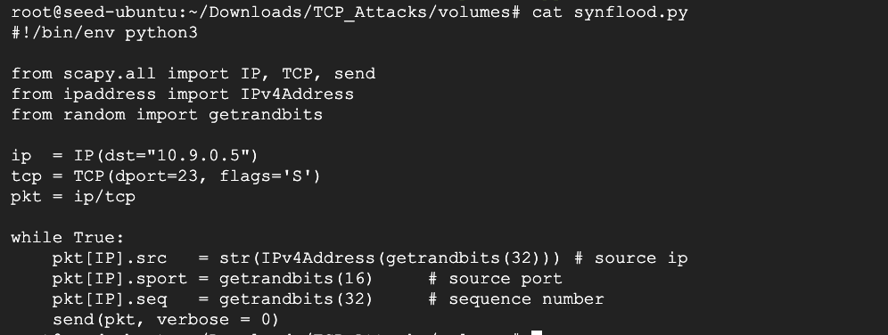

**Execution of SYN flooding attack using python code**

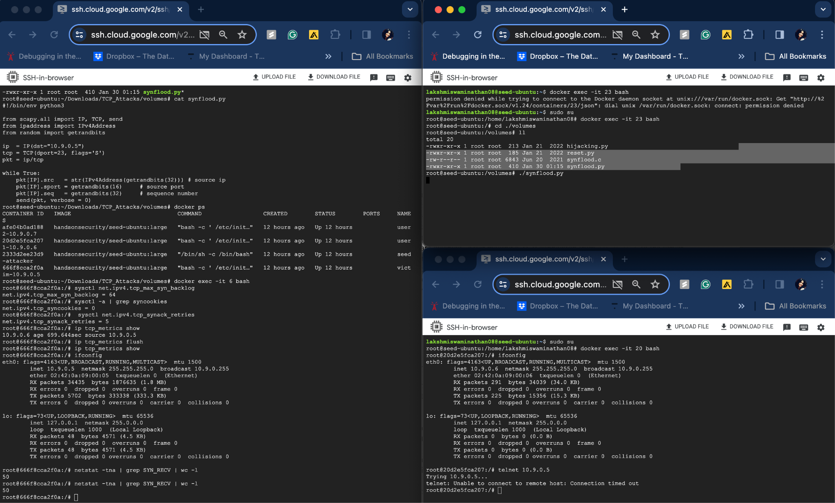

TCB queue size is set to 64 as python code before executing SYN flooding Attack as python code to fill up TCB queue is a bit slower. The SYN flooding attack succeded and telnet connection attempt to 10.9.0.5(victim - TCP server) failed.

**Task 1.2**: SYN flooding attack using C code

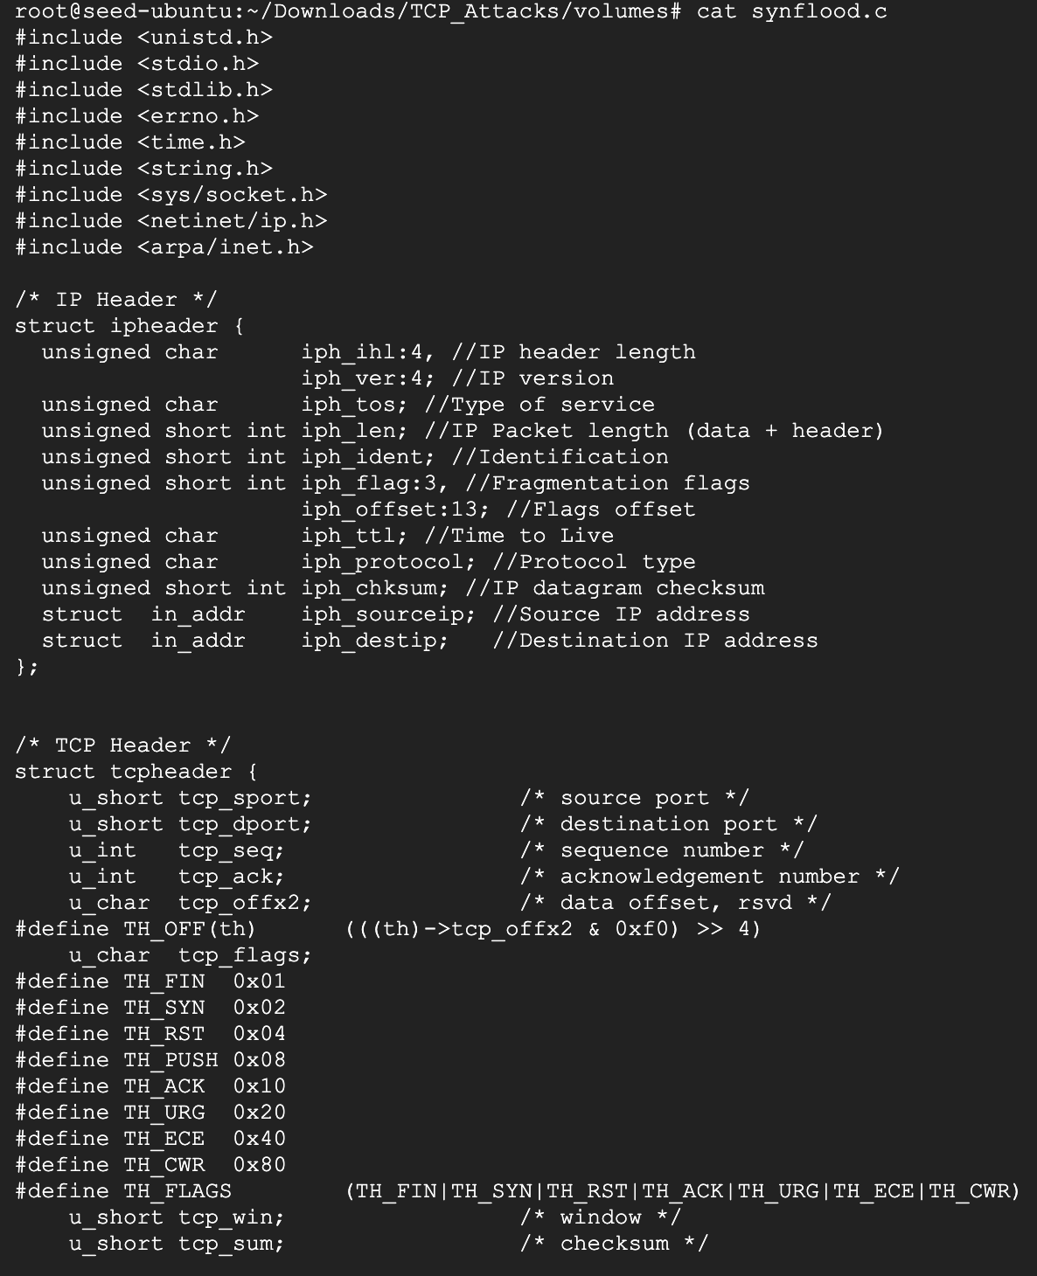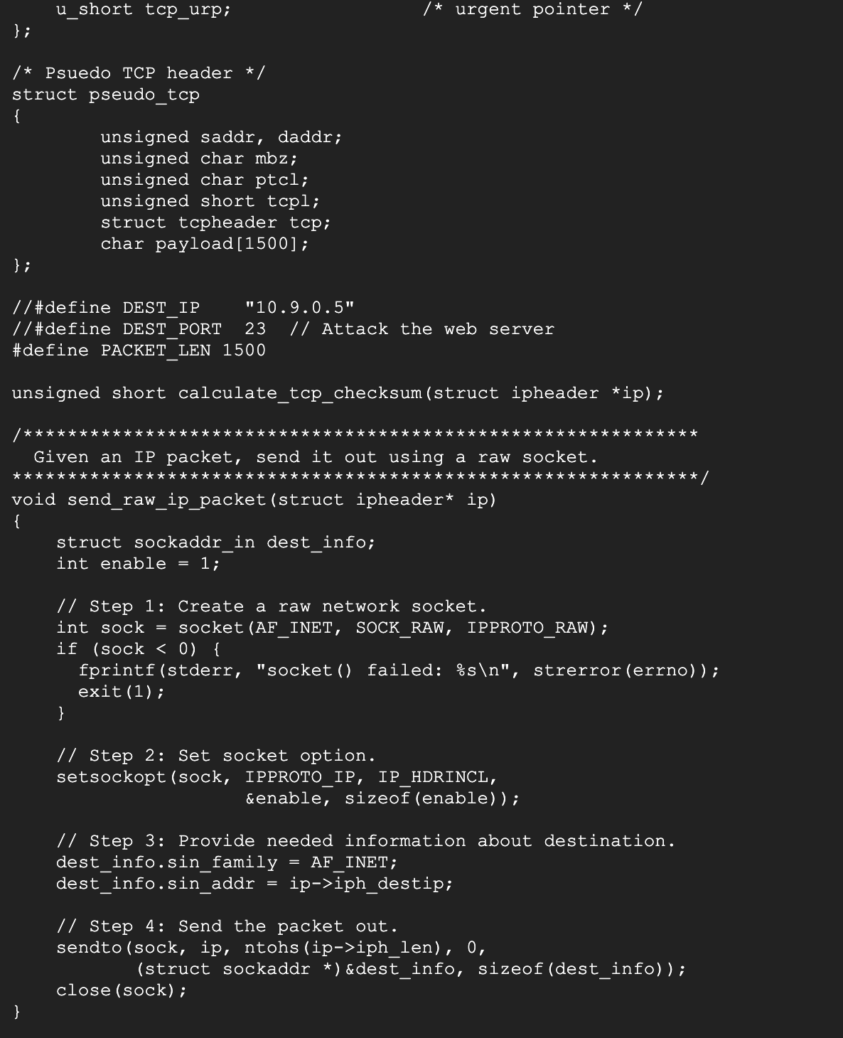

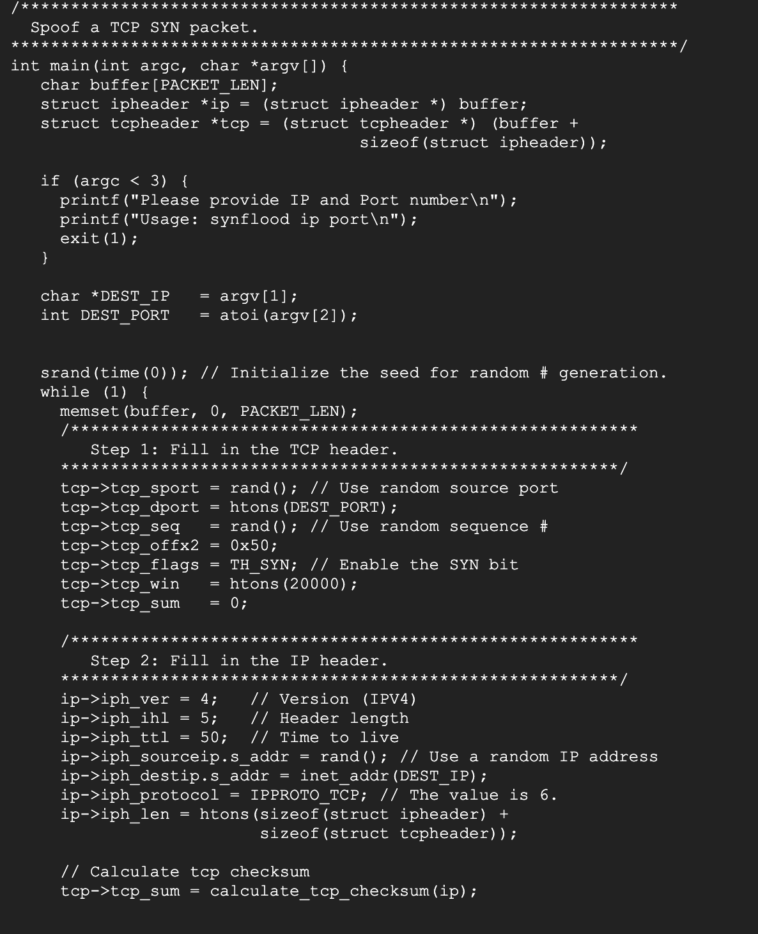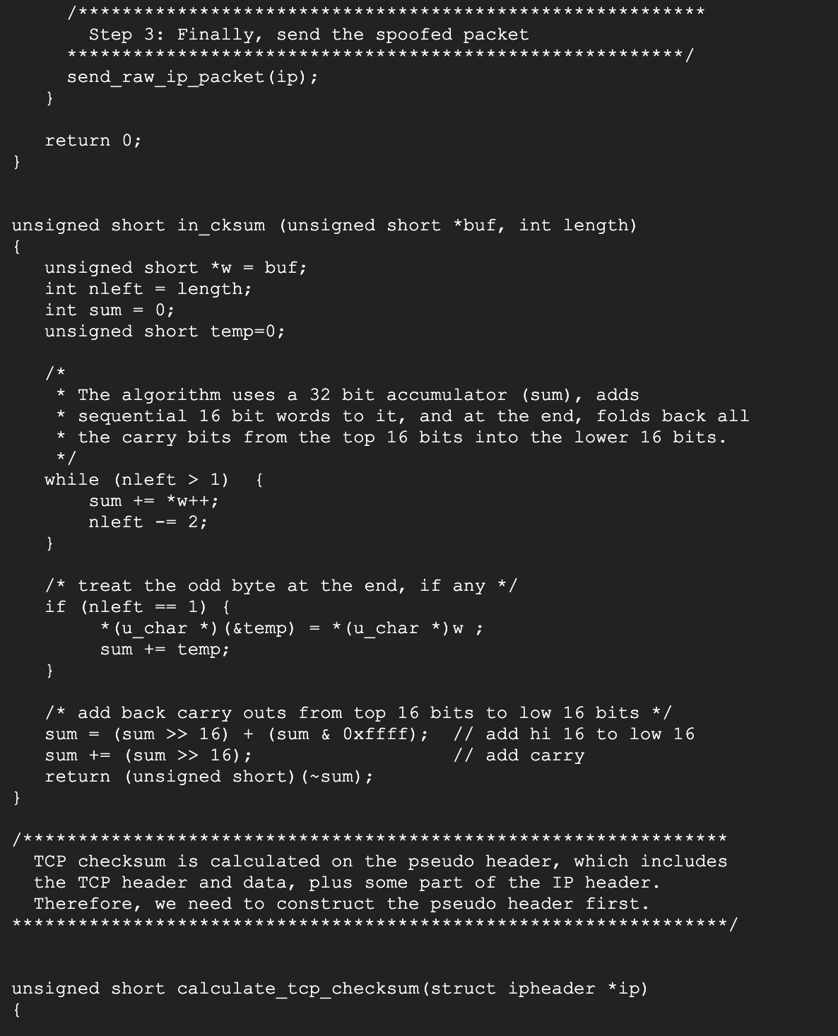

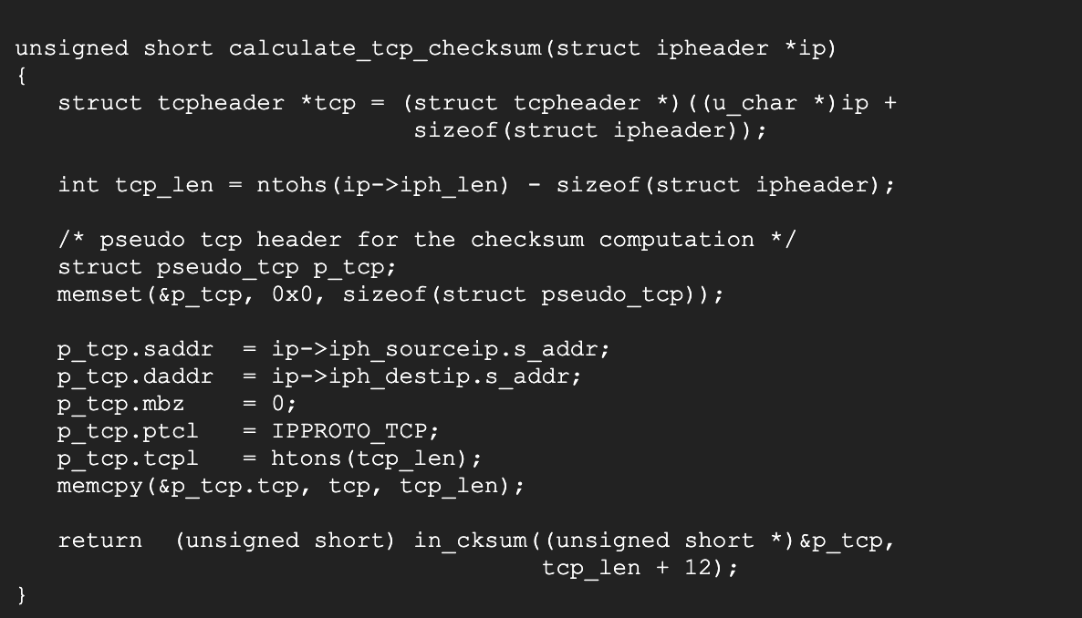

Execution of SYN flooding attack using C code

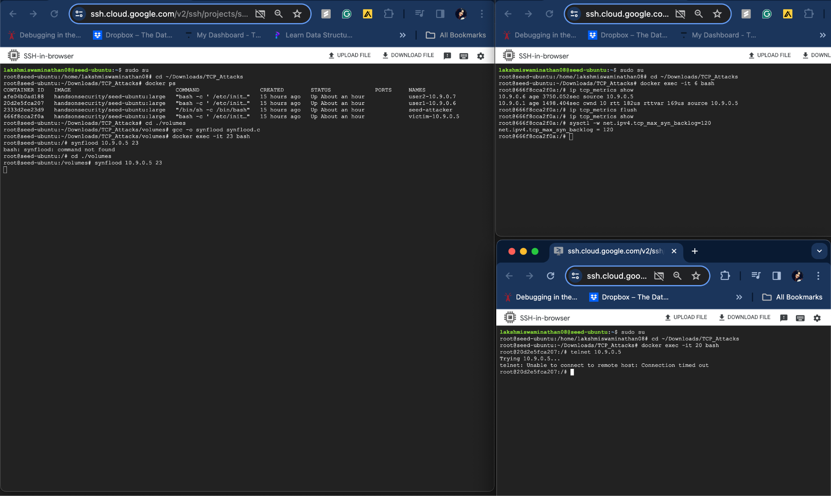

TCB queue size is set to 120. The SYN flooding attack succeded and telnet connection attempt to 10.9.0.5(victim - TCP server) failed.

**Task 1.3:**

**Execution of SYN Flooding attack using Python code with SYN Cookie Countermeasure enabled**

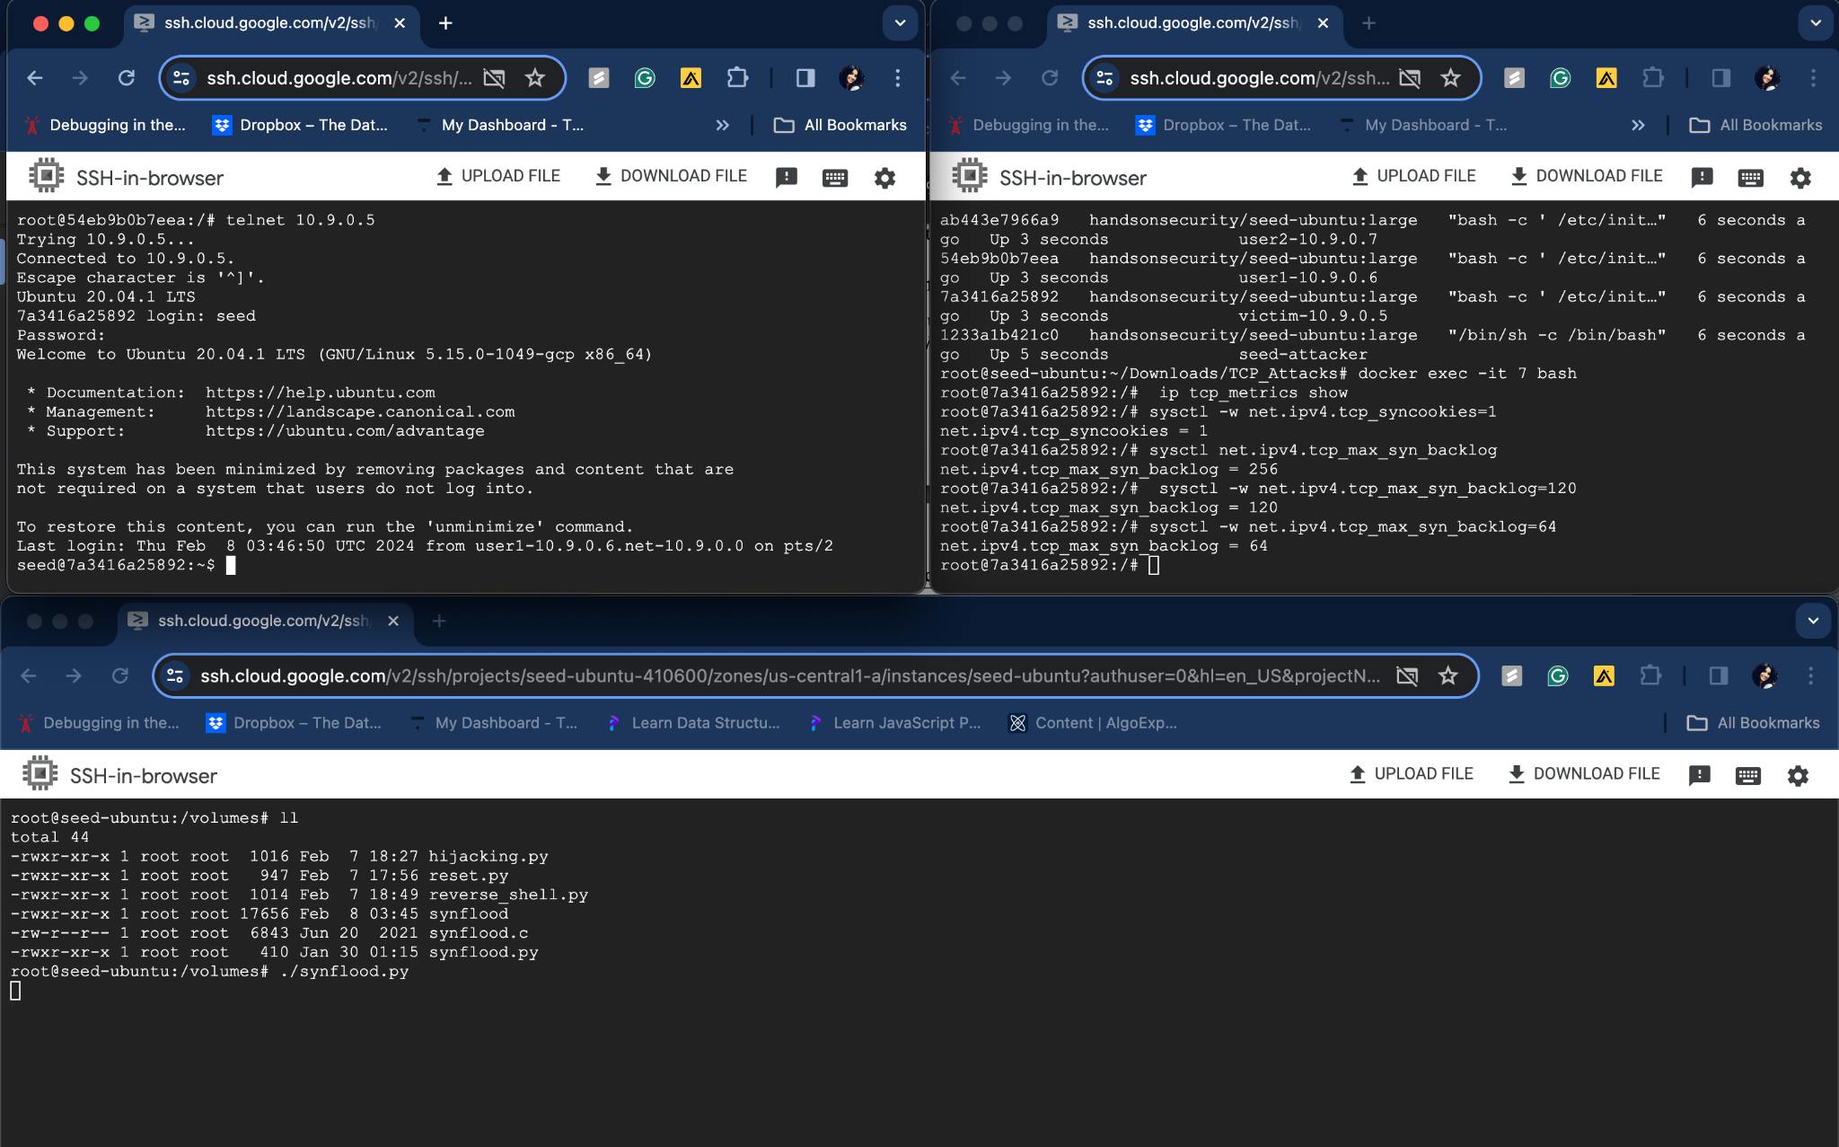

TCP Synflooding attack didn’t succeed and host is able to successfully telnet to 10.9.0.5. Denial of service of attack using TCP SYN Flooding failed when SYN cookie countermeasure is enabled.

**Execution of SYN Flooding attack using C code with SYN Cookie Countermeasure enabled**

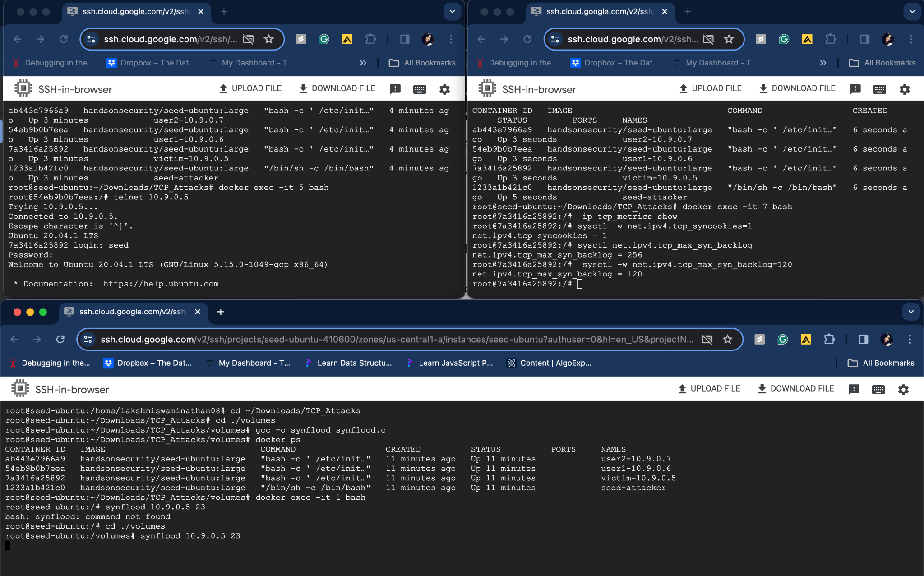

TCP Synflooding attack didn’t succeed and host is able to successfully telnet to 10.9.0.5. Denial of service of attack using TCP SYN Flooding failed when SYN cookie countermeasure is enabled.

**Task 2: TCP RST Attacks on telnet Connections**

TCP RST attack on telnet connection python code:

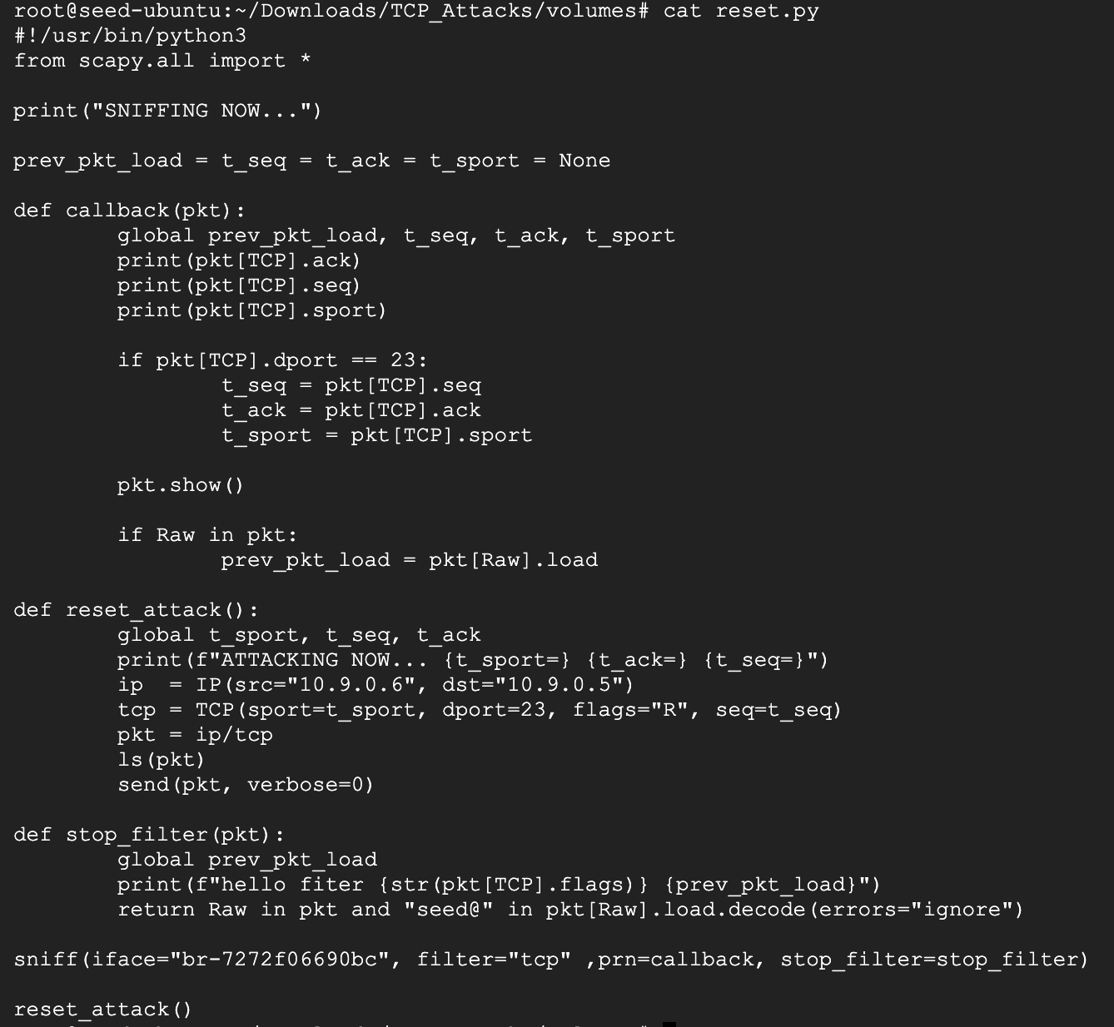

Execution of TCP RST attack on telnet connection:

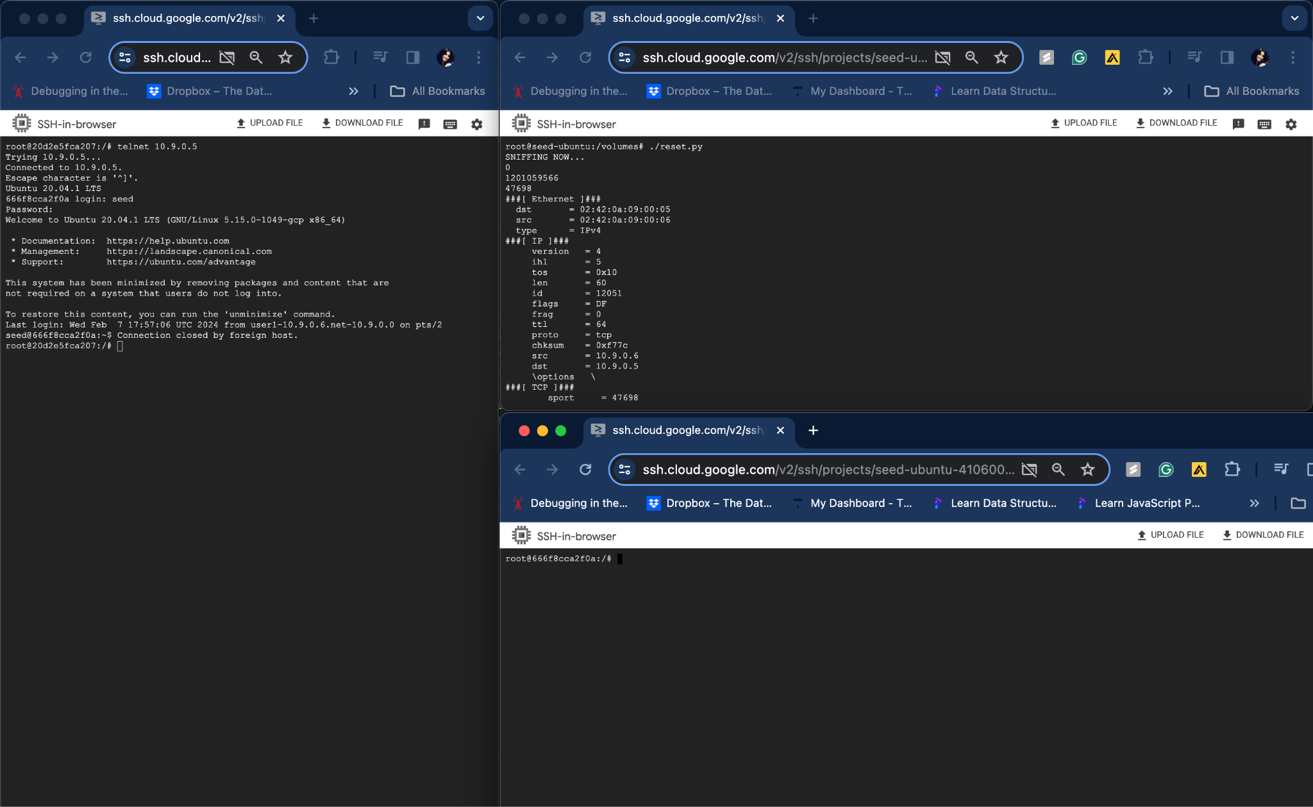

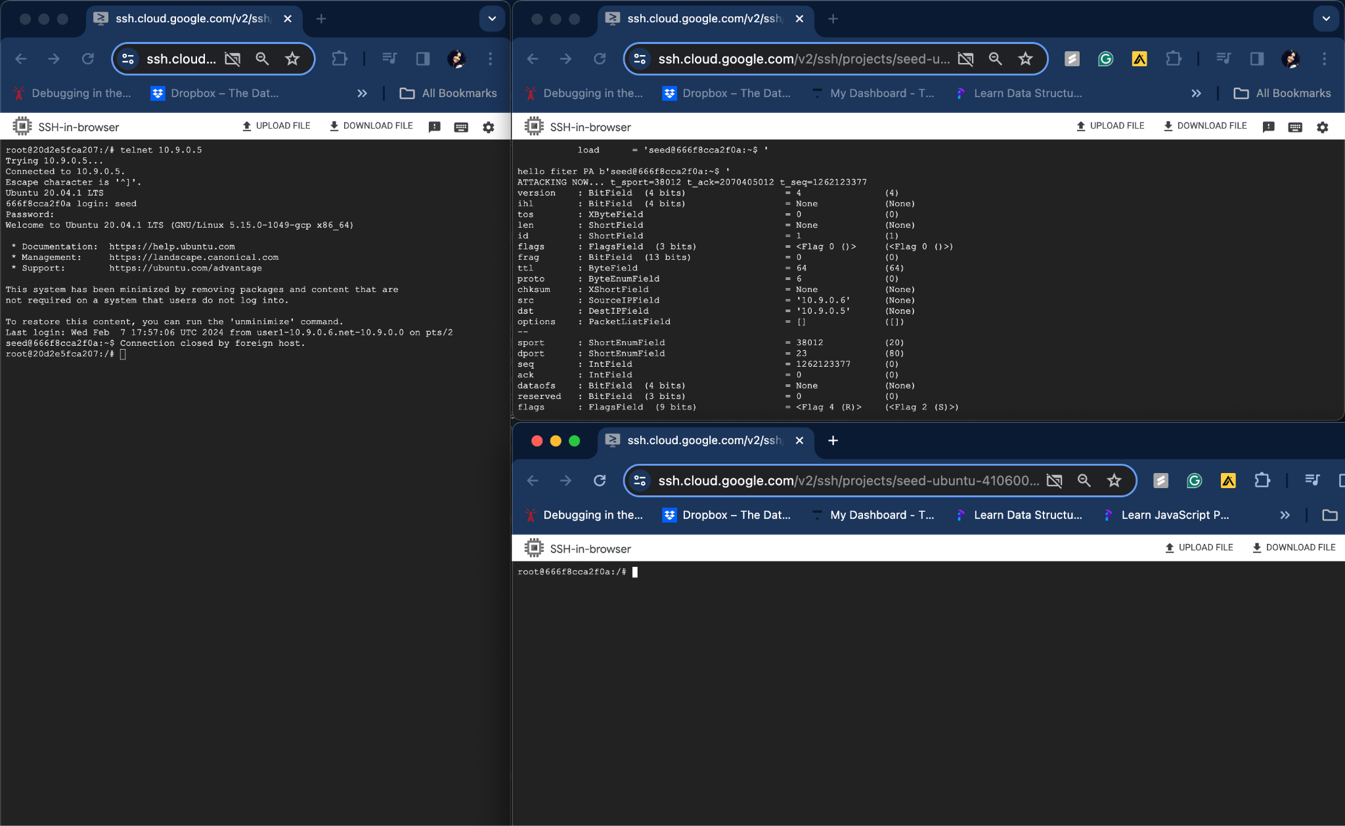

The TCP connection(telnet connection to 10.9.0.5) is successfully closed by TCP reset attack. The entire attack is automated where source port, Sequence number, Acknowledgement number are all sniffed and spoofed using python scapy code instead of using wireshark.

**Task 3: TCP Session Hijacking**

Code for TCP session hijacking

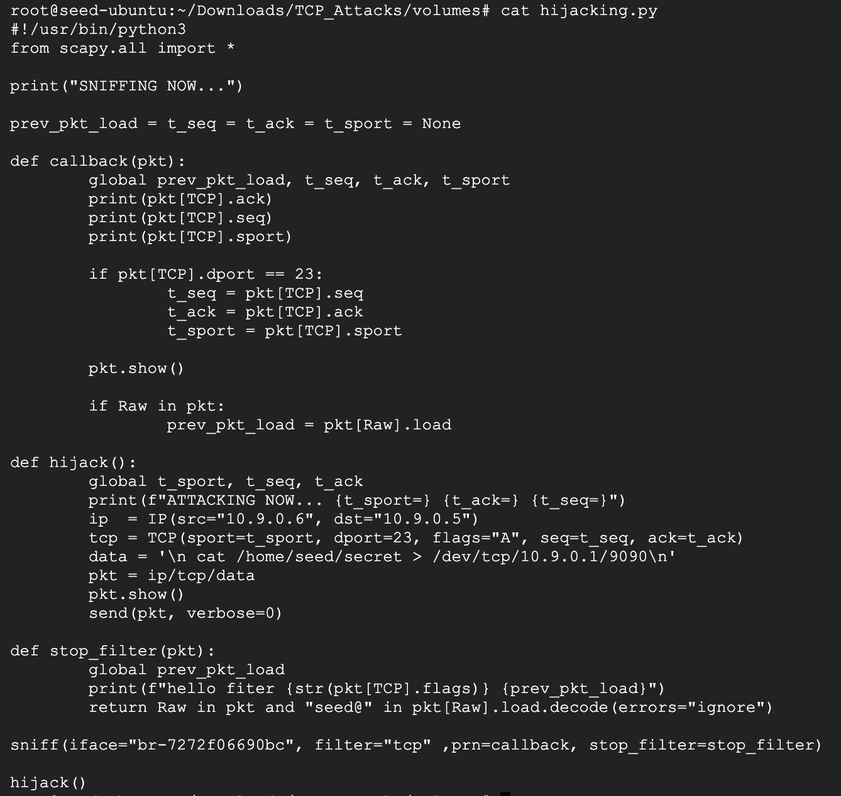

Execution of TCP session hijacking attack:

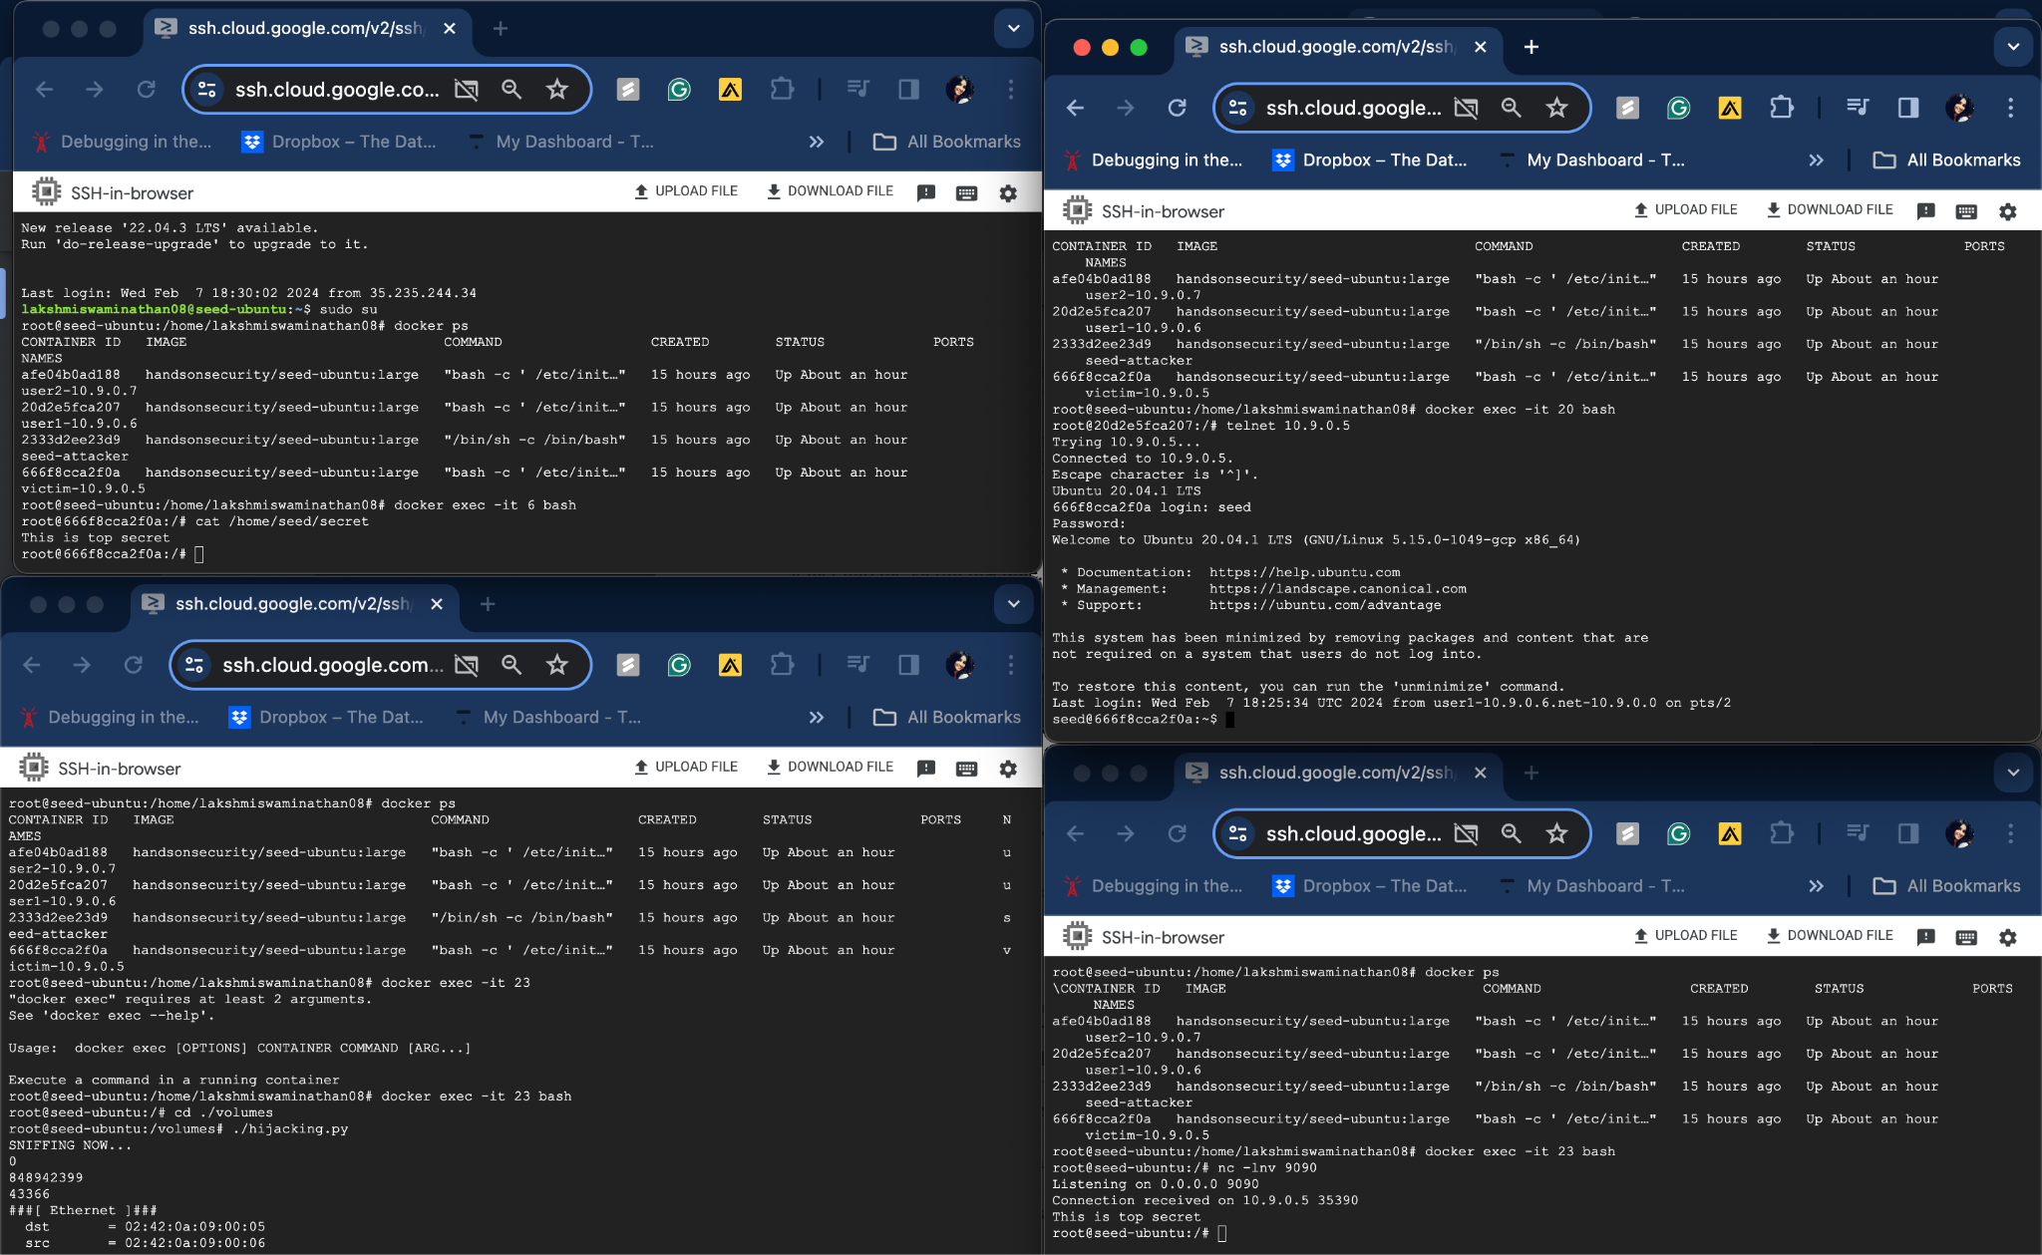

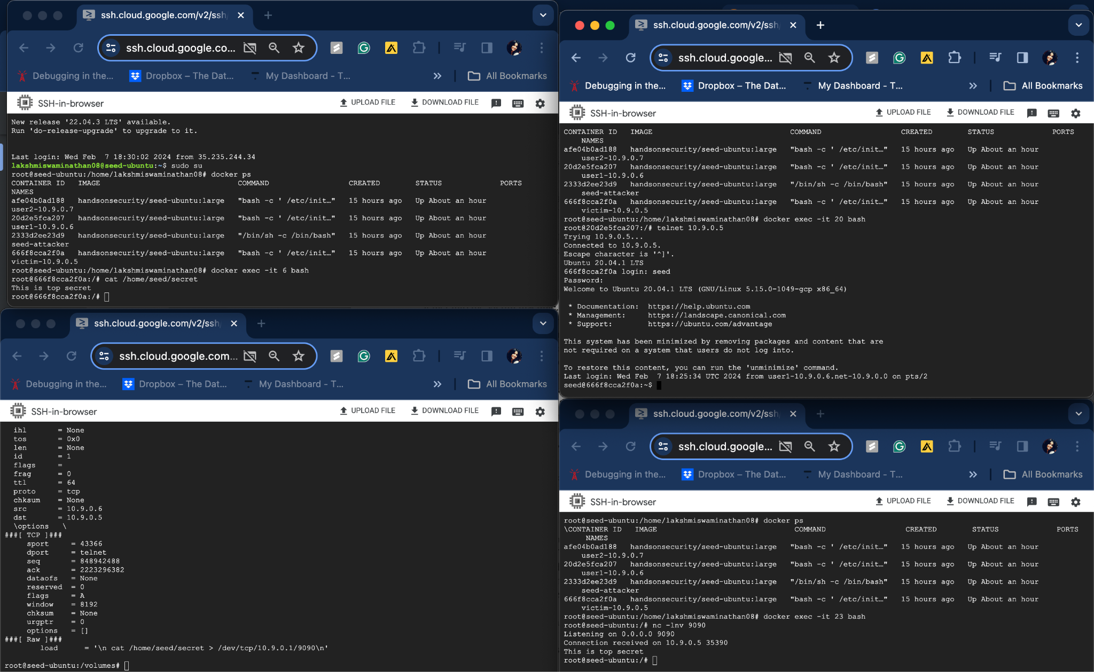

The TCP connection(telnet connection) is successfully hijacked and the contents of secret file of the victim is successfully displayed in the attacker container. The entire attack is automated where source port, Sequence number, Acknowledgement number are all sniffed and spoofed using Python Scapy code instead of using Wireshark.

**Task 4: Creating Reverse Shell using TCP Session Hijacking**

Code for Reverse Shell using TCP session hijacking:

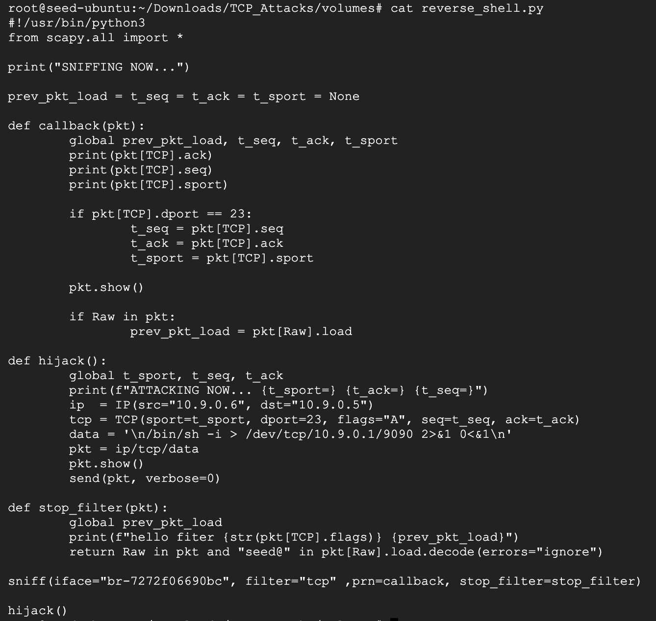

Execution of Reverse Shell using TCP session hijacking:

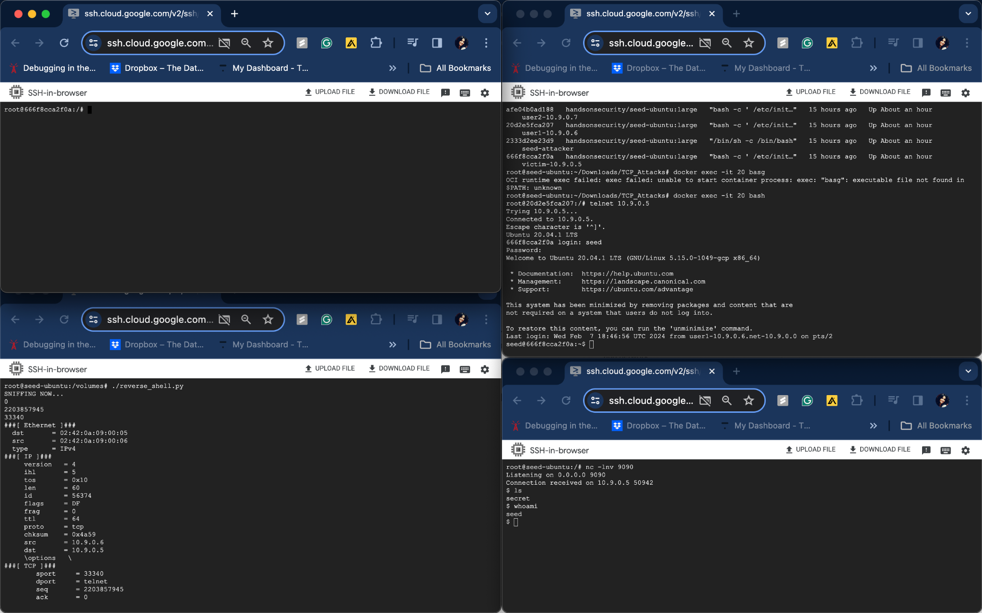

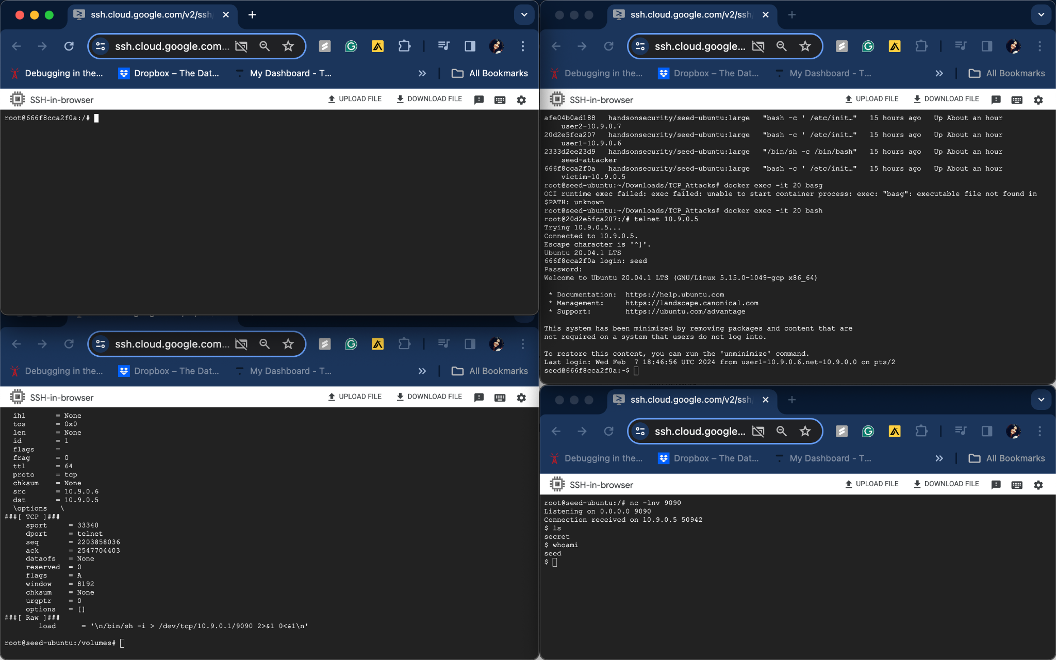

The TCP connection(telnet connection) is successfully hijacked and the execution of reverse shell of victim is successful. The entire attack is automated where source port, Sequence number, Acknowledgement number are all sniffed and spoofed using Python Scapy code instead of using Wireshark.